**"Cash Machine System"**

**NMJ11004 COMPUTER PROGRAMMING**

**ACADEMIC SESSION 2021/2022**

**MINI PROJECT**

**FINAL REPORT**

**GROUP 12**

**1.ZWE HTET NAI NAI**  **211020042-5**

**2.ABDULRAHMAN ABDULRAKEB ALI 211020047-5**

**3.ABDULMAJEED SALEH BIN MAHFOODH 221020015-5**

**FACULTY OF ELECTRONIC ENGINEERING & TECHNOLOGY**

**UNIVERSITI MALAYSIA PERLIS**

**Introduction**

The project we developed is the basic c-program for automatic teller machine. It is fully functional for the user to initiate, deposit and withdraw the money. The purpose of this program is to help a user to experience the actual atm from a simple console. Programming techniques such as functions, strings, looping are used to develop this program.

The objective of this simple program is that to access a person's bank balance easily from a local atm nearby. The machine often conveniently provide access to cash on a 24/7 basic, without the need to personally see a representative from the bank. ATM machines make your cash more accessible and are quick and simple to use, once you get used to it. It also saves plenty of time to go an wait at the bank to withdraw your own money.

Since this is just a prototype/basic system, there are certain limitations. This project is to point out the main functions of an ATM such us deposit, withdrawal and checking the personal statement only. For that the user is supposed to have his money deposited in the system. However, in this system, we developed it for the user to initiate the amount of money he wants to start with his name.

**Lists of system functionalities**

1. Choosing the options for specifics tasks: input data should be the integers which refers to each of their particular task such as choosing to initialize the system, depositing, checking balance and withdrawing cash.
2. Money Depositing: this will accept the value from the user for how much he or she want to deposit into the account. For this, incrementation will be used here because the new amount is going to add up to the current amount that user possess.
3. Withdrawing money: this functionality will ask the user how much money he or she want to withdraw. After the user enter the preferred amount to withdraw, the program will check the desired amount is satisfied with the balance. This only works if balance is more the desired withdrawal amount. If _ else conditional statement is used to perform this task.

**THE PSEODU CODE:**

**Begin**

**Fanction prototype** display initial page, check the balance of money, display money, withdraw money, exit and **error message.**

Declaring int, float, char.

Read please enter your name

Declaring name

Read please enter your balance to initiate

Read welcome (the name of user) to cash machine ATM system

Declaring while (repeat)

Display initial page

Read select the task

Declaring switch (option)

Case 1:

Read check balance

Case 2:

Read balance = money deposit

Case 3:

Balance = money withdraw

Case 4:

Read menu exit

Declare default == errorMessage

Read would you like to do another transaction

Read <1> for **Yes**, <2> for **No**

If choose ==1

Read true

Else

Read false

Declaring initial page

Read please choose one of the options below

Read < 1 > Check Balance

Read < 2 > Deposit

Read < 3 > Withdraw

Read < 4 > Exit

Declaring check balance

Read ("You Choose to See your Balance")

Read Your Available Balance is….

Declaring money deposit

Read You choose to Deposit a money

Read Your Balance is…

Read Enter your amount to Deposit

balance += deposit;

Read Your New Balance is…

Display money Withdraw

Read the Balance

Declaring while (back)

Read ("Enter your amount to withdraw:\n");

if (withdraw < balance)

Read Your withdrawing money

Read Your New Balance

Else

Read You don't have enough money

Read ("Please contact to your Bank Customer Services\n");

Read ("****Your Balance is: $%.2f\n\n", balance);

Declaring menuExit

Display Take your receipt

Display ("-----Thank you for using ATM Banking Machine!!!-----\n");

Declaring errorMessage the name

Read You selected invalid number

**Strings** 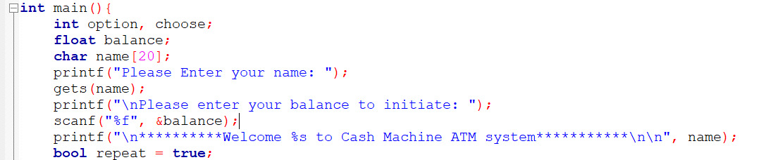

Strings are used here to provide the user with better user experience to display in the welcoming page. The main function accepts the string from user to enter his or her name.

**Conditional** 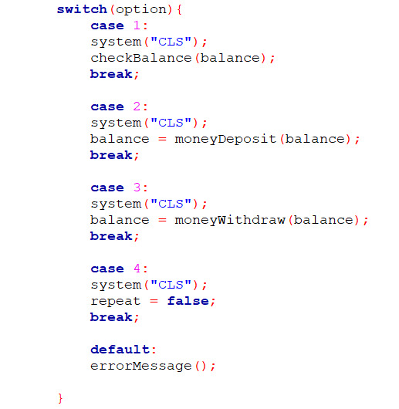

Switch statement is used in the main function to choose the certain task for user to use.

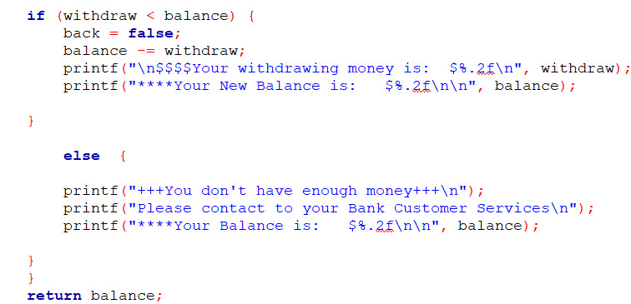

If else statement is also used to check the balance of the user's bank account is below or above the user's desired withdrawal amount.

**Repetition**

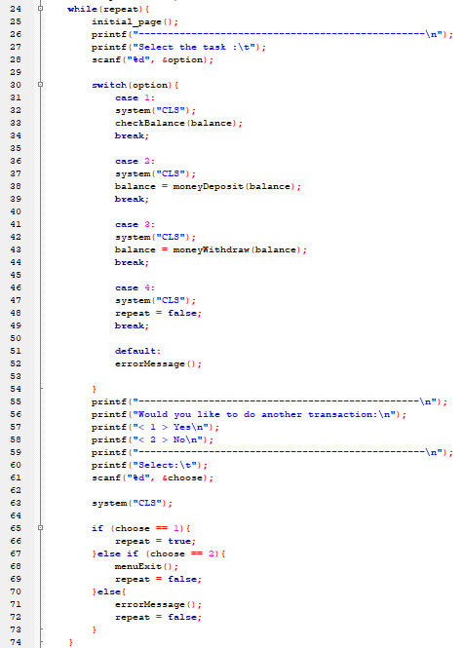

While loop is used in the main function to keep asking user which task, he or she want to do until the user terminate it by certain keyword provided in the screen. After the user completed one task, the program will continue to ask the user if he or she want to continue to perform other task.

**Functions**

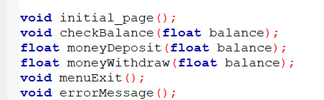

The functions are used here to perform specific tasks such as checking the balance, depositing the money and withdrawing the money according to the user's input request.

Input of the program:

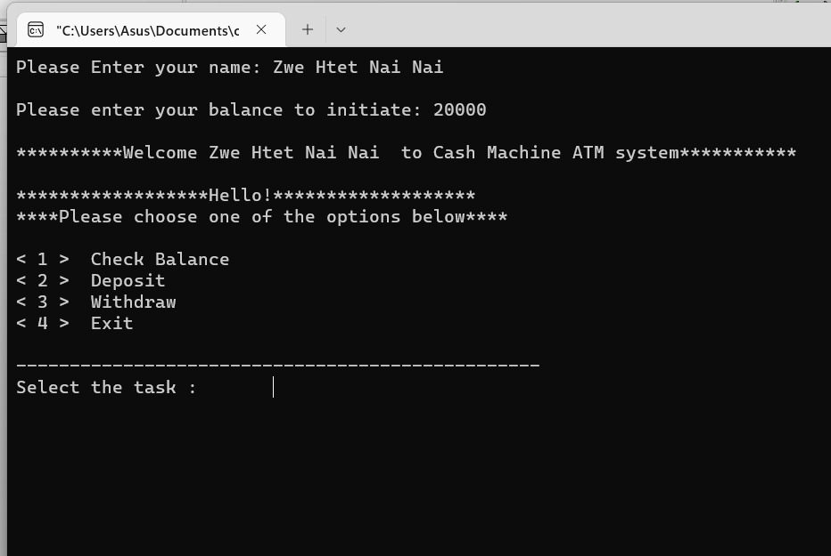

Firstly, The program asks the user to enter name and the initial amount first. After that, the user can choose which type of task he or she would like to perform.

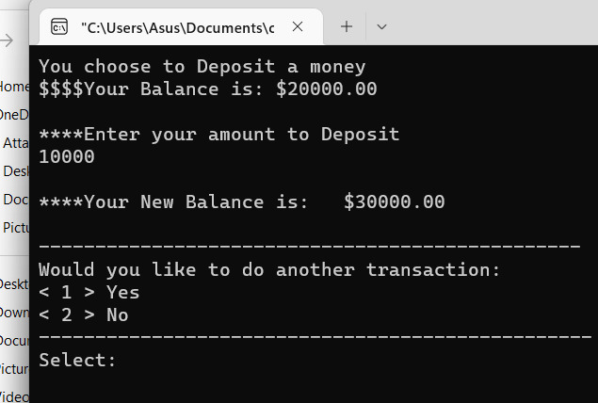

For choosing depositing, the user can deposit more money into initial balance.

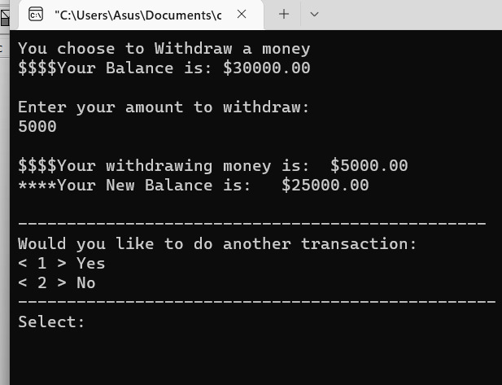

For choosing withdrawing , the user can take out cash from the existing balance and it will be subtracted from the balance.

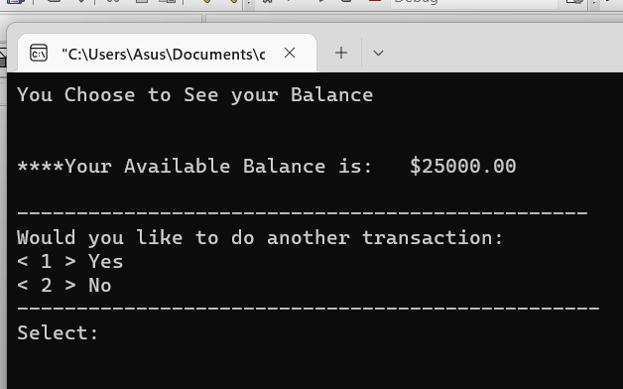

For checking the balance, the user can just choose the balance checking option from the main menu and this window with balance will be appeared.

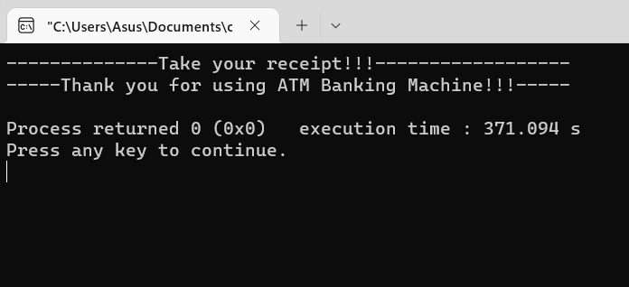

For exiting, the user will be log out of choosing task option to continue to ask him or her to choose more or want to quit the program. After exiting the good bye function will be executed and the program will be stopped.

**Discussion**

This is just a basic program to demonstrate the process of the ATM. For more advanced system, we can create multiple users log in with 2 dimensional arrays and we can also create the username and password with other techniques. During the process of developing this system, we have faced the problems with passed by reference functions. That’s why we decided to use pass by value because it was more suitable for this program.

**The code :**

**#include <stdio.h>**

**#include <stdlib.h>**

**#include <stdbool.h>**

**#include <string.h>**

**void initial_page();**

**void checkBalance(float balance);**

**float moneyDeposit(float balance);**

**float moneyWithdraw(float balance);**

**void menuExit();**

**void errorMessage();**

**int main(){**

**int option, choose;**

**float balance;**

**char name[20];**

**printf("Please Enter your name: ");**

**gets(name);**

**printf("\nPlease enter your balance to initiate: ");**

**scanf("%f", &balance);**

**printf("\n*********Welcome %s to Cash Machine ATM system**********\n\n", name);**

**bool repeat = true;**

**while(repeat){**

**initial_page();**

**printf("-------------------------------------------------\n");**

**printf("Select the task :\t");**

**scanf("%d", &option);**

**switch(option){**

**case 1:**

**system("CLS");**

**checkBalance(balance);**

**break;**

**case 2:**

**system("CLS");**

**balance = moneyDeposit(balance);**

**break;**

**case 3:**

**system("CLS");**

**balance = moneyWithdraw(balance);**

**break;**

**case 4:**

**system("CLS");**

**repeat = false;**

**break;**

**default:**

**errorMessage();**

**}**

**printf("------------------------------------------------\n");**

**printf("Would you like to do another transaction:\n");**

**printf("< 1 > Yes\n");**

**printf("< 2 > No\n");**

**printf("-------------------------------------------------\n");**

**printf("Select:\t");**

**scanf("%d", &choose);**

**system("CLS");**

**if (choose == 1){**

**repeat = true;**

**}else if (choose == 2){**

**menuExit();**

**repeat = false;**

**}else{**

**errorMessage();**

**repeat = false;**

**}**

**}**

**return 0;**

**}**

**//**

**void initial_page(){**

**printf("******************Hello!*******************\n");**

**printf("***Please choose one of the options below***\n\n");**

**printf("< 1 > Check Balance\n");**

**printf("< 2 > Deposit\n");**

**printf("< 3 > Withdraw\n");**

**printf("< 4 > Exit\n\n");**

**}**

**//Check Balance**

**void checkBalance(float balance) {**

**printf("You Choose to See your Balance\n");**

**printf("\n\n****Your Available Balance is: $%.2f \n\n", balance);**

**}**

**//money deposit**

**float moneyDeposit(float balance) {**

**float deposit;**

**printf("You choose to Deposit a money\n");**

**printf("$$$$Your Balance is: $%.2f\n\n", balance);**

**printf("****Enter your amount to Deposit\n");**

**scanf("%f", &deposit);**

**balance += deposit;**

**printf("\n****Your New Balance is: $%.2f\n\n", balance);**

**return balance;**

**}**

**//money withdraw**

**float moneyWithdraw(float balance) {**

**float withdraw;**

**bool back = true;**

**printf("You choose to Withdraw a money\n");**

**printf("$$$$Your Balance is: $%.2f\n\n", balance);**

**while (back) {**

**printf("Enter your amount to withdraw:\n");**

**scanf("%f", &withdraw);**

**if (withdraw < balance) {**

**back = false;**

**balance -= withdraw;**

**printf("\n$$$$Your withdrawing money is: $%.2f\n", withdraw);**

**printf("****Your New Balance is: $%.2f\n\n", balance);**

**}**

**else {**

**printf("+++You don't have enough money+++\n");**

**printf("Please contact to your Bank Customer Services\n");**

**printf("****Your Balance is: $%.2f\n\n", balance);**

**}**

**}**

**return balance;**

**}**

**//exit menu**

**void menuExit() {**

**printf("--------------Take your receipt!!!------------------\n");**

**printf("-----Thank you for using ATM Banking Machine!!!-----\n");**

**}**

**//error message**

**void errorMessage() {;**

**printf("+++!!!You selected invalid number!!!+++\n");**

**}**

***The End, thank you for your time…***